THE CHARITIES ACT (NORTHERN IRELAND) 2008
THE CHARITIES ACT (NORTHERN IRELAND) 2013
THE CHARITY TRIBUNAL RULES (NORTHERN IRELAND) 2010

The Charity Tribunal for Northern Ireland

Appeal Reference: 3/19

Review Hearing Friday 5 July 2019

Before

Damien J. McMahon
President

Between

Trevor McKee
Appellant
and

THE CHARITY COMMISSION FOR NORTHERN IRELAND
Respondent

Decision

UPON READING correspondence dated 24 September 2019 from the Appellant that he wished to withdraw his appeal;

And upon the Appellant orally confirming his wish to withdraw his appeal at the review hearing held on Friday, 5 July 2019;

AND UPON the Respondent’s counsel at the said review hearing confirming that the Respondent had no objection;

IT IS ORDERED THAT:

- this Appeal is formally dismissed pursuant to Rule 24(1) of the Charity Tribunal Rules (Northern Ireland) 2010.

- No order as to costs.

Signed

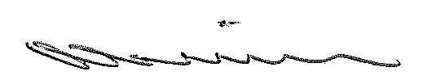

Damien J. McMahon
President

Date: 4 October 2019

