THE CHARITIES ACT (NORTHERN IRELAND) 2008
THE CHARITIES ACT (NORTHERN IRELAND) 2013
THE CHARITY TRIBUNAL RULES (NORTHERN IRELAND) 2010

The Charity Tribunal for Northern Ireland

Appeal Reference: 4/19

Review Hearing 5 July 2019

Before

Damien J. McMahon
President

Between

PRISON SERVICE TRUST
Appellant
and

THE CHARITY COMMISSION FOR NORTHERN IRELAND
Respondent

Decision

UPON READING correspondence dated 19 June 2019 from the solicitors for the Appellant that the Appellant wished to withdraw its appeal;

And upon reading from counsel for the Respondent at the Review Hearing that the Respondent had no objection;

IT IS ORDERED THAT:

- the Appeal is formally dismissed pursuant to Rule 24(1) of the Charity Tribunal Rules (Northern Ireland) 2010.

- No order as to costs.

Signed

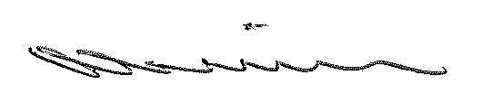

Damien J. McMahon]
President

Date: 4 October 2019

