THE CHARITIES ACT (NORTHERN IRELAND) 2008
THE CHARITIES ACT (NORTHERN IRELAND) 2013
THE CHARITY TRIBUNAL RULES (NORTHERN IRELAND) 2010

The Charity Tribunal for Northern Ireland

Application Reference: 6/16

Sitting in Chambers

Before

Damien J. McMahon
President

Between

ROBERT CRAWFORD
Appellant
-and-

THE CHARITY COMMISSION FOR NORTHERN IRELAND
Respondent

Decision

UPON READING correspondence dated 9 April 2020 from the Respondent’s Legal Adviser confirming that the Respondent was withdrawing its opposition to this appeal in its entirety;

And there being no objection from the Appellant;

IT IS ORDERED THAT:

- This appeal is formally allowed pursuant to Rule 24(2) of the Charity Tribunal Rules (Northern Ireland) 2010.

- Pursuant to section 13(6) and (7) of the Charities Act (Northern Ireland) 2008, the Tribunal makes no order as to costs.

Signed

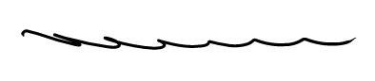

Damien J. McMahon
President

Date: 21 September 2020

