THE CHARITIES ACT (NORTHERN IRELAND) 2008
THE CHARITIES ACT (NORTHERN IRELAND) 2013
THE CHARITY TRIBUNAL RULES (NORTHERN IRELAND) 2010

The Charity Tribunal for Northern Ireland

Appeal Reference: 1/19

Sitting in Chambers

BETWEEN
JOBY FOX (RFTA)

Appellant
-and-

THE CHARITY COMMISSION FOR NORTHERN IRELAND

Respondent
-and-

THE ATTORNEY-GENERAL FOR NORTHERN IRELAND

Intervening Party

DECISION

UPON READING correspondence dated 07/07/2021 from the Appellant’s representative confirming that the Appellant wished to withdraw this appeal in its entirety;

And UPON there being no objection from the Respondent or the Intervening Party;

IT IS ORDERED THAT:

- This appeal is formally dismissed pursuant to Rule 24(2) of the Charity Tribunal Rules (Northern Ireland) 2010.

- Pursuant to section 13(6) and (7) of the Charities Act (Northern Ireland) 2008, the Tribunal makes no order as to costs.

Signed
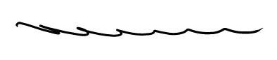

Damien J. McMahon
President,
Charity Tribunal for Northern Ireland.

Date: 8 July 2021

