THE CHARITIES ACT (NORTHERN IRELAND) 2008
THE CHARITIES ACT (NORTHERN IRELAND) 2013
THE CHARITY TRIBUNAL RULES (NORTHERN IRELAND) 2010

The Charity Tribunal for Northern Ireland

Application Reference: 1/20

Sitting in Chambers

Before

Damien J. McMahon
President

Between

WOODVALE & SHANKILL COMMUNITY HOUSING ASSSOCIATION LIMITED
Applicant
and

THE CHARITY COMMISSION FOR NORTHERN IRELAND
Respondent

Decision

UPON READING correspondence dated 23 June 2020 from the solicitors for the Applicant that the Applicant wished to withdraw its application;

And upon reading correspondence from a solicitor for the Respondent dated 24 June 2020 that the Respondent had no objection;

IT IS ORDERED THAT:

- the Application is formally dismissed pursuant to Rule 24(1) of the Charity Tribunal Rules (Northern Ireland) 2010.

- No order as to costs.
Signed

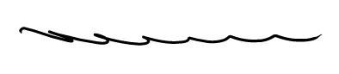

Damien J. McMahon]
President

Date: 10 July 2020

